Market Potential Assessment of Kentucky for 2020
Original 17 October 2019
Updated 9 November 2019

Purpose:
Identify market potential, demand, capability, and vision for the Commonwealth of Kentucky for Calendar Year 2020

Market Analysis:
The map below shows the population density in the Commonwealth, and is indicative of the available market – There are 4.5 million residents in Kentucky

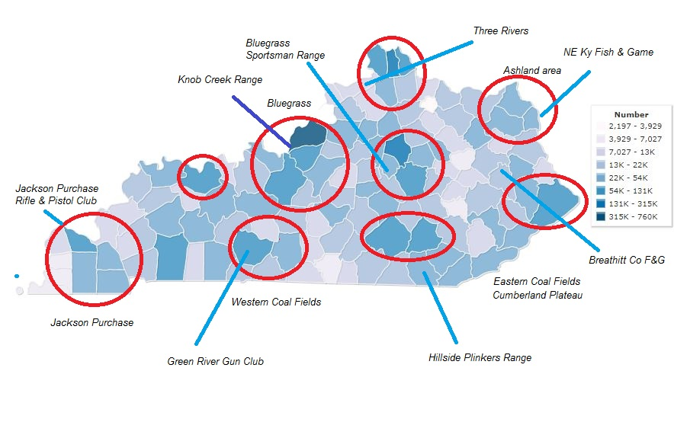

https://www.indexmundi.com/facts/united-states/quick-facts/kentucky/population#map

Metro centers:

Louisville
Lexington
Covington/Cincinnati

Other areas of interest:

Asheville
Pikeville
London/Corbin
Paducah
Bowling Green area
Owensboro

PRODUCT

- Appleseed, 25 meter – Capable at all historic Kentucky AS ranges
- Appleseed, KD – Restricted by distance; need to identify a new KD range – not offered in 2019
- Liberty Seed – Any instructor with any group
- Patriot Pistol – 10 Meter, any Appleseed range – not realized yet in Kentucky
- Mini-seed – Yet to be realized in Kentucky (see annex 1)
- Appleseed KD 100yd – Yet to be realized in Kentucky

PLACEMENT

( Name/ last event / capacity/ narrative assessment/agreement status)

- Knob Creek, West Point – Last event September 2019. Capacity 22 shooters. Key range serving the largest population. The range is said to be within commuting distance of 40% of the Commonwealth population. Very good covered facilities, separate range for AS, excellent range store nearby, some noise issues from other ranges, requires porta potty. No Agreement in hand.

- Rockcastle Shooting Center, Park City – Last known event was KD in September 2018. Capacity about 20. Uncovered positions. Current support issues. No agreement in hand.

- Kentucky Regulators Gun Club, Boaz– Last known event in 2014. Capacity unknown. Uncovered positions. No agreement in hand

- Jackson Purchase Rifle and Pistol, Paducah Last event date unknown. Capacity 24. Weekend availability only of 5th Saturday-Sunday. Good facilities. Shoot boss must be a club member. Agreement on file in the Forum in 2016

- Breathitt County, Jackson Fish & Game – Last known event in 2014. Capability: 20 shooters (estimated). Positive commitment in October 2019 for future events . Good indoor area for briefings. Range positions are uncovered. Remote location along Hy 30 heading east. Agreement on file in Forum in 2014

- North Eastern Kentucky Fish and Game, Ashland – Last known event in 2010. Capacity 20 shooters (estimated). No Agreement in hand.

- Three Rivers Shooting Sports, Carrollton - Last known event was in 2009. Capacity unknown. No Agreement in hand.

- Green River Gun Club, Bowling Green - Last known event was in 2013 – Capacity unknown Good facilities and support. Possible 2020 event, TBD. No Agreement in hand.

- Clear Creek Shooting Range, Morehead Last known event was in about 2014. Capacity 20 shooters. No Agreement in hand.

- Hillsdale Plinkers, Williamsburg. Last known event was 2012. Capacity unknown. No Agreement in hand.

Neighboring States’ Appleseed Ranges
which may support underserved Kentucky areas – 1 hour for 25m, 1.5 hour for KD

- Clinton County Farmers and Sportsman Association, Wilmington, Ohio – Last known event was 20 October 2019. Capacity 20. (one hour from Covington- AAR presented a very good venue with excellent results)

- Ararat Farm Range, Jonesville, TN – Last known event 18 October, Capacity 10+?, (45 minutes from Harlan through Pennington Gap) AAR presented a good venue https://appleseedinfo.org/smf/index.php?topic=51145.msg344713;topicseen#msg344713

- Camp Atterbury, IN, (IN ARNG) – Last known event…., Capacity 15+? (1 hr 24 min from Louisville) KD range – active base, special pass requirements. See here https://appleseedinfo.org/smf/index.php?topic=43174.msg305804#msg305804

- Egyptian Rifle & Pistol Club, Marion IL – Last known event May 2019 (LesMoore). Capacity 10+, (1 hour from Paducah)

- Puryear, TN – Last known event April 2019 (LesMoore). Capacity 10+(1 hour from Paducah, Good facilities) https://appleseedinfo.org/smf/index.php?topic=55531.0
PRICE

Nationally set https://appleseedinfo.org/pricing-information/

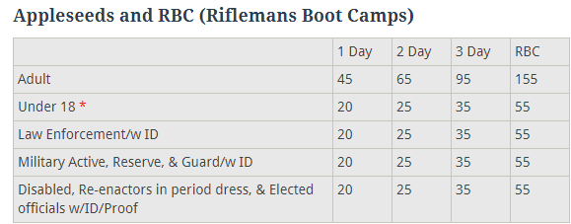

* At Shoot Boss discretion, some shooters may have free admission. There may be consideration for a special-group shoot with reduced pricing subject to justification and approval by the RC and NC.

PROMOTION

As of this time there is limited physical promotion in the Commonwealth to a few gun shops to my personal knowledge and word-of-mouth. There were no Gun Show tables set up. For 2020 there may be benefit to contact high-potential groups such as JROTC, CAP, Scouts, 4-H, Sherriff and Police departments, USAR and NG, and gun clubs around the state especially (all subject to resource availability)

The standard National Appleseed promotion effort is working to bring some shooters to Commonwealth events.

Social Media: Guntuckian continues to run the Kentucky AS Facebook board and reports good following and makes frequent historical and event news posts.

PEOPLE

The availability of staff is a key limiting factor to frequent and dispersed events. Kentucky must recruit and develop additional staff in order to offer more events around the state. Hopefully to target recruiting in geographically underserved areas.

Staff on hand as we enter the 2020 year.

- Master Instructor – 1
- Senior Instructor – 0
- Designated Shoot Boss – 1
- Shoot Boss – 1
- Instructors – 4
- Instructors in Training – 2
- AppleCore - 1

Conclusion:

The lack of staff, and the availability of staff, seems to be the most important limiting factors. There are several historic ranges that are seemingly available, although Agreements are not on file and cannot be located. An effort to recruit and train additional shoot bosses would seem to be the best way ahead to improve the number and location of events, and to increase participation thorough increased opportunity and local promotion.

Mark S Carroll
CarrollMS
State Coordinator
11/9/19

Appendix
1 – Mini-Seed plan
2 – Historic shoots and annual statistics with links to IAARs
Annex 1 Mini Seed Plan
(from here https://appleseedinfo.org/smf/index.php?topic=51621.msg346942#msg346942 )
See FAQ- Not listed nationally, not insured. Qualifies Riflemen with Red Hat if already attended a full AS

What: Would you like to practice your marksmanship skills under the watchful eye of qualified RSO/Instructors? Come out for a mini-seed. You'll be glad you did.

Why: Several students have approached with a desire for personalized coaching or an opportunity to shoot multiple AQTs to refine or renew their basic skills. It's also hot now (Inferno-seed HOT) and most people are reluctant to come to the range for a two-day event. By the time they get around to shooting AQTs they are worn out. For these reasons we will be conducting a mini-seed at the Port Malabar Rifle & Pistol Club's Smallbore Range.

How: The POI for the second day of a two-day event will be pared down to the essentials for safety. Instruction will be tailored to the needs of the students. After a safety briefing there will be a fast-paced review of SHF, Six Steps of Firing the Shot, NPOA and IMC. One sighter sheet will be shot and then we'll move on to AQTs. Expert shooters will earn the coveted Rifleman patch.

Who: Let's get the word out to our past students. Spaces will be available on the line for Instructors to requalify.

Where: TBD

Date/Time: TBD (We will start promptly at 8:00am. At Noon we will assess whether to continue until 4:30)
Attendance: Limited to x students

Prerequisite: Attendance at a prior Appleseed event. New shooters will be referred to sign up at a full Appleseed.

Cost: Free

Equipment: Smallbore rimfire rifle, 1-1/4" GI sling with attachments and swivels, 250-400 rounds of ammo.

Personal Comfort/Survival Gear: Lunch, snacks, water, sunscreen, bug repellent, hat, eye and ear protection, towel and rain gear.

Contact for more information: Name, phone, email.

Appendix 2: Historical Statistics

Calendar Year 2019

4 Appleseed events total: 21 shooters, new Riflemen 5
- 4 Appleseed 25m events, attendance 21, new Riflemen 5

Apr 27, 2019, Knob Creek, 25m, Shooters 9, Riflemen 1
https://appleseedinfo.org/smf/index.php?topic=55742.0
Jun 8, 2019, Knob Creek #6672, 25m, Shooters 3, Riflemen 1
https://appleseedinfo.org/smf/index.php?topic=56107.0
Aug 17, 2019, Knob Creek #6673 , Shooters 7, Riflemen 1, 7th 1 OH
https://appleseedinfo.org/smf/index.php?topic=56582.0
Sep 28 2019, Knob Creek, Shooters 12, Riflemen 2 , 7th step 2 OH
https://appleseedinfo.org/smf/index.php?topic=56970.0

Calendar Year 2018

4 Appleseed events total, 32 shooters, 7 new riflemen, 5 KD rockers
- 3 Appleseed 25M, attendance 21, new Riflemen 7,
- 1 Appleseed KD, attendance 11, KD, 7th Step 1 AC, 1 ITT0

Apr 18 2018, Knob Creek #5954, 25M, Shooters 9, Riflemen 0, requal 2
https://appleseedinfo.org/smf/index.php?topic=53609.msg356028#msg356028
Jun 16 2018, Knob Creek #5955, 25M, shooters 8, Riflemen 2, Requal 1, 7th none
https://appleseedinfo.org/smf/index.php?topic=53940.msg357549#msg357549
Jul 14, 2018, Park City #5928 25M, shooters 4, Riflemen 0,
https://appleseedinfo.org/smf/index.php?topic=54046.msg358067#msg358067
Sep 15 2018, Park City #5929, KD, shooters 11, Riflemen 5, KD 5, Requal 1, 7th 2 BH, 1 OH
https://appleseedinfo.org/smf/index.php?topic=54369.msg359867#msg359867

Calendar Year 2017

5 Appleseed events total, 38 shooters, 13 new riflemen
- 5 Appleseed 25M, attendance 38, new Riflemen 13

April 8 2017, JP-R&P Paducah, 25m, shooters 5, Riflemen 1
https://appleseedinfo.org/smf/index.php?topic=50765.msg343021#msg343021
April 22 2017, Knob Creek, 25M, shooters 9, Riflemen 4, Requal 1
https://appleseedinfo.org/smf/index.php?topic=50887.msg343799#msg343799
Jun 24, 2017, Knob Creek, 25M, shooters 9, Riflemen 4, Requal 1
https://appleseedinfo.org/smf/index.php?topic=51467.msg346221#msg346221
Sep 16 2017, Knob Creek 25m, shooters 10, Riflemen 3
https://appleseedinfo.org/smf/index.php?topic=52150.msg349292#msg349292
Oct 14, 2017, Boaz 25M, shooters 5, Riflemen 1, Requal 1
https://appleseedinfo.org/smf/index.php?topic=52280.msg349888#msg349888

