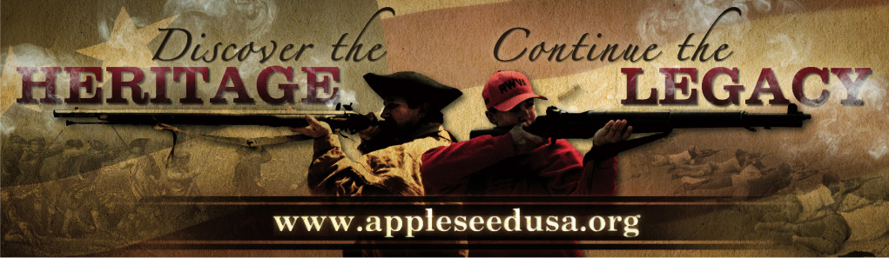
Project Appleseed
Rifle Marksmanship Clinic
Is Coming to Soldotna – Majority Arms LLC Range!
Saturday & Sunday May 17-18, July 26-27 & Sept. 20-21, 2014

{Other 2014 Alaska Events: Chugiak AK Apr 19; Talkeetna June 14-15;
Tok June 28-29; Chugiak AK July 12-13; Chugiak AK Aug 09-10; Talkeetna Aug 16-17; Chugiak AK Sept 13-14; Chugiak AK Oct 11-12; Chugiak AK Nov 01;
See Full Listing at website as we will be adding more locations!}
Project Appleseed is the sole project of the Revolutionary War Veterans Association (RWVA),
a 501(c)(3) organization. Founded in 2006, Project Appleseed and its volunteers are committed to bringing traditional rifle marksmanship skills and the story of April 19, 1775, to each and every American. Our goal is to teach the skills that are truly ours alongside the story, engaging each participant in our unique American heritage and encouraging all to become active and engaged citizens.

Cost is $60 per weekend for Adults, $20 for Youth under 18
Active Duty Military, Guard, & Reserves, Peace Officers, Elected Officials, Revolutionary War Re-enactors FREE.
Range fees are, if applicable, not included in registration fees and are payable on-site.
See event info on the website for more info, including directions and start times.
Rifles and ammunition are not supplied, but we can assist you with getting a loaner.

For more information about
Online Pre-Registration, What to Bring, and What to Expect, visit:
www.appleseedUSA.org

Or Contact: rwva@live.com or wthomas@gci.net

Marksmanship, History, Heritage*Marksmanship, History, Heritage * Marksmanship, History, Heritage

