APPLESEED 300
Coupon and Registration Directions

If you have attended an Appleseed event in the past, you can shoot free at the Appleseed 300 on 11-12 Sep 2010 at the Aurora Sportsman’s Club in Waterman, IL. To do this, you will need to do two things:
SIGN UP ONLINE USING THE CODE “WM 300” SO THAT YOU ARE PRE-REGISTERED
BRING PROOF OF PRIOR APPLESEED EXPERIENCE WITH YOU TO THE REGISTRATION TABLE

In order to ensure that we have a place for you on this long line of riflemen, please register online at http://www.eventbrite.com/event/617389629. Ensure that you enter the special discount promotional code “WM 300” (without the quotation marks) so that you are not charged.
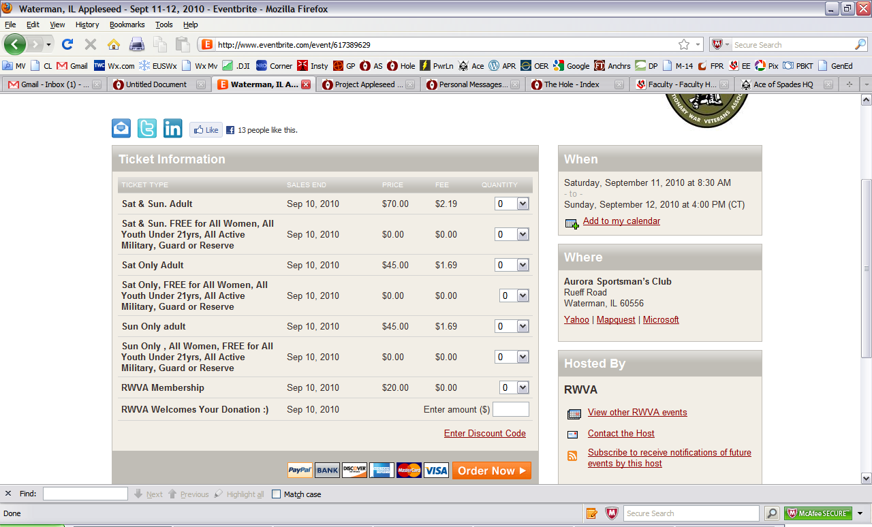

WHAT COUNTS AS PROOF OF PRIOR APPLESEED EXPERIENCE?

To shoot free at the Appleseed 300 you need to bring one of four forms of evidence showing that you have already attended an Appleseed to the Registration Table on the day of the shoot:
AN EVENTBRITE TICKET STUB
A CANCELED CHECK
A SCORED AQT (Army Qualification Test)
THE COUPON BELOW, SIGNED AND DATED BY YOUR SHOOT BOSS

NAME _____________________________________ DATE: __________________

LOCATION: __________________ SHOOT BOSS: ______________________________

