RIFLE MARKSMANSHIP

3-POSITION SHOOTING CLINIC
& HISTORY OF THE AMERICAN REVOLUTION

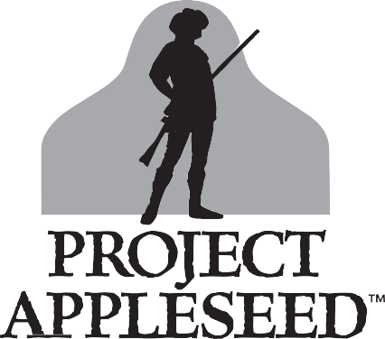

Project Appleseed™ is part of a nationwide, non-profit, educational organization that teaches rifle marksmanship skills and the history of our Nation’s founding. Events will include instruction on gun safety and proper techniques from multiple shooting positions, using modern rifles.
WHAT YOU WILL LEARN:

Rock Solid Shooting Positions Using a Sling for Support Natural Point of Aim
Six Steps to Firing a Shot Shot Analysis
Inches, Minutes & Clicks
Sight Adjustment & Range Estimation History and Heritage
Students will also have the opportunity to earn the coveted Rifleman patch by shooting a qualifying score on the Appleseed Qualification Test (AQT).

RIFLEMAN

FLORIDA STATE SCHEDULE
Always check the official schedule and register at appleseedusa.org

FLORIDA STATE HOST RANGES
or visit one of our many ranges across the USA
Got a club or other organization? We’ll come to you!
Pensacola

What you should bring:
St. Augustine | FL | March 09, 2019 - March 10, 2019
Tallahassee | FL | March 09, 2019 - March 10, 2019
Myakka City | FL | March 23, 2019 - March 24, 2019
Gainesville | FL | March 30, 2019 - March 31, 2019
Hurlburt Field | FL | March 30, 2019 - March 31, 2019
Pensacola | FL | April 06, 2019 - April 07, 2019
Hollywood | FL | April 13, 2019 - April 14, 2019
Bunnell | FL | April 27, 2019 - April 28, 2019
Hernando | FL | April 27, 2019 - April 28, 2019
Myakka City | FL | April 27, 2019 - April 28, 2019
Palm Bay | FL | April 27, 2019 - April 28, 2019
Tallahassee | FL | April 27, 2019 - April 28, 2019
Hurlburt Field | FL | May 04, 2019 - May 05, 2019
Clearwater | FL | May 18, 2019 - May 19, 2019
Orlando | FL | May 18, 2019 - May 19, 2019
Palm Bay | FL | May 18, 2019 - May 19, 2019
Tallahassee | FL | May 18, 2019 - May 19, 2019
Bunnell | FL | June 08, 2019 - June 09, 2019
Myakka City | FL | June 15, 2019 - June 16, 2019
Palm Bay | FL | June 15, 2019 - June 16, 2019
Gainesville | FL | June 29, 2019 - June 30, 2019
Myakka City | FL | August 03, 2019 - August 04, 2019
Bunnell | FL | August 10, 2019 - August 11, 2019
Hernando | FL | September 07, 2019 - September 08, 2019
Hurlburt Field | FL | September 07, 2019 - September 08, 2019
Hernando | FL | October 05, 2019 - October 06, 2019
Myakka City | FL | October 05, 2019 - October 06, 2019
Pensacola | FL | October 05, 2019 - October 06, 2019
Clearwater | FL | October 19, 2019 - October 20, 2019
Palm Bay | FL | October 19, 2019 - October 20, 2019
Bunnell | FL | October 26, 2019 - October 27, 2019
Hurlburt Field | FL | November 02, 2019 - November 03, 2019
Clearwater | FL | November 16, 2019 - November 17, 2019
Palm Bay | FL | November 16, 2019 - November 17, 2019
Myakka City (FD) | FL | November 23, 2019 - November 24, 2019
Gainesville | FL | November 30, 2019 - December 01, 2019
Hernando | FL | December 07, 2019 - December 08, 2019
Myakka City | FL | December 07, 2019 - December 08, 2019
Palm Bay | FL | December 21, 2019 - December 22, 2019
Myakka City | FL | January 18, 2020 - January 19, 2020

★ A desire to learn and improve

2 Hurlburt Field
7

8 Tallahassee
Gainesville
4

St Augustine
11
3 Bunnell

★ A rifle, sighted in at 25 meters, if possible
★ Shooting sling highly recommended
- inexpensive GI type web slings work best
★ 250 rounds of ammunition per day

Central FL Rifle & Pistol Club
- Escambia River Gun Club

Brooksville
New Smyrna
14 Beach

★ Eye and ear protection, mat or ground cloth

Flagler Gun and Archery Club
- Gainesville Target Range
5 Orlando
1
Palm

★ Hat and sunscreen, rain gear, layered clothes
★ Water, lunch, snacks, family and friends!

5 Hernando Sportsman's Club
Clearwater
15
10 Bay

Hollywood Rifle & Pistol Club
- Hurlburt Field Rifle and Pistol Club
- Isaac Davis Memorial Range
- Manatee Gun & Archery Club
- Port Malabar Rifle & Pistol Club
- Saltwaters Shooting Club
- Shoot Shack Gun Range & Archery Club
- South Florida Training Grounds
- Volusia County Gun and Hunt Club
- Wyoming Antelope Club
12 Lithia
9 Myakka City
Immokalee
13
6
Ft Lauderdale
/ Hollywood

2018-19 Rifle Clinic Fees:

Adults - $60
Youth Under 18 - $20
Active Military, Reserve, Peace Officer, Disabled, Re-enactors in period dress, elected officials w/ID - $20 Some ranges also ask for a modest range fee, paid upon arrival
(FD) Full Distance events, shot out to 400 yards or even further, require a centerfire rifle. Prior Appleseed attendance may be required.
(RBC) Rifleman Boot Camps are usually 5-7 days & may also include shooting to full distance.
(Ladies) events are for women & girls only.
(Rimfire) events only allow .22 Rimfire Rifles to be used.
Most other events allow both Centerfire and Rimfire Rifles to be used.
www.appleseedusa.org

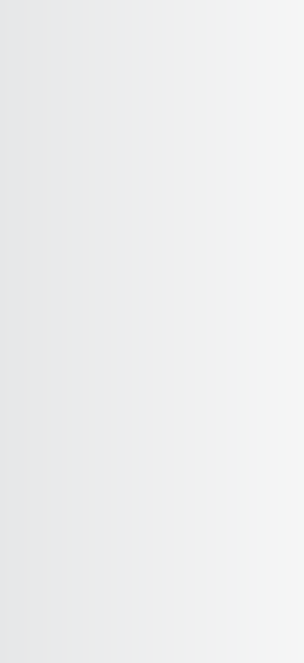Learn More, Find a Shoot Near You & Register at:
www.appleseedusa.org
facebook.com/ProjectAppleseedFL

Florida State: FL@appleseedinfo.org North FL: (850) 668-0410
Central FL: (727) 452-4650

