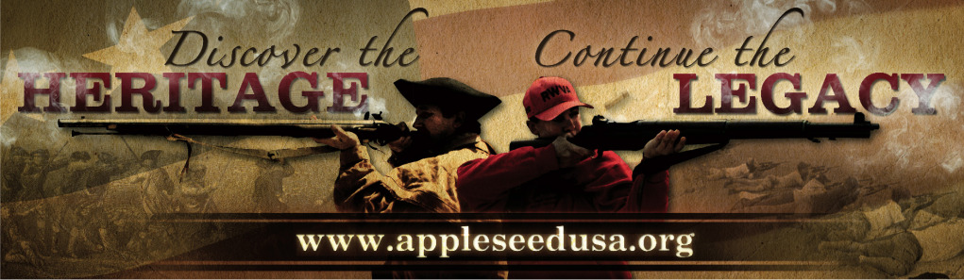
Project Appleseed Alaska
2019 Marksmanship Clinics
Chugiak – Birchwood Range – March 16 & 17
Chugiak – Birchwood Range – April 27 & 28
Kodiak – KISA Rifle & Pistol Range May 18 & 19
Talkeetna – Upper Susitna Shooters Range – June 22 & 23
Soldotna – Majority Arms LLC Range August 10 & 11
Chugiak – Birchwood Range – October 12 & 13
Chugiak – Birchwood Range – November 9 “Winterseed”

Project Appleseed is the sole project of the Revolutionary War Veterans Association (RWVA),
a 501(c)(3) organization. Founded in 2006, Project Appleseed and its volunteers are committed to bringing traditional rifle marksmanship skills and the story of April 19, 1775, to each and every American. Our goal is to teach the skills that are truly ours alongside the story, engaging each participant in our unique American heritage and encouraging all to become active and engaged citizens.

Cost is $60 per weekend for Adults, $20 for Youth under 18,
Active Duty Military, Guard, & Reserves, Peace Officers, Elected Officials $20.
Range fees are not included in registration fees and are payable on-site – depending on venue. $20 per day.
See event info on the website for more info, including directions and start times.
Rifles and ammunition are not supplied, but we can assist you with getting a loaner.

For more information about
Online Pre-Registration, What to Bring, and What to Expect, visit:

www.appleseedinfo.org

Or Contact:
Scott Newson – Twheel747@yahoo.com

Marksmanship, History, Heritage * Marksmanship, History, Heritage * Marksmanship, History, Heritage

