


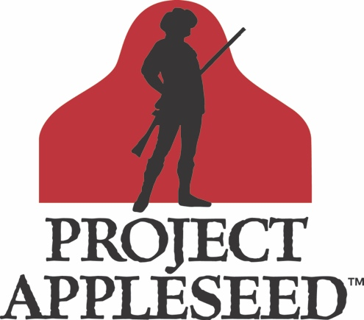
Rifle Marksmanship Clinic
& Stories of the American Revolution

Map/ Directions/GPS
www.appleseedinfo.org
Learn More, Find a Shoot Near You and Register at:
www.appleseedinfo.org
facebook.com/projectappleseed
facebook.com/FloridaAppleseed
*Most shooting is done at 25 meters using reduced scale targets, to simulate actual distance. Some events also include further distances.
Attendees are responsible for determining applicable firearms laws of the host state and for travel. For more info, go to http://myfloridalegal.com
For questions about the event, contact (name, email, phone)
History • Heritage • Marksmanship
Fees: Adults - $60 (Saturday and Sunday included!)
Youth Under 18 - $20
FREE - (With appropriate ID) Active Military, Reserve,
Guard, Peace Officers, Elected Officials, or Disabled
(Prices do not include range fees, usually $10-20)
What you should bring:
 A desire to learn and improve.
 Centerfire, .22 rimfire rifle (or both)
 Scope OK. GI Web Sling strongly recommended.
 250 rounds of ammunition per day, per rifle
 Eye and ear protection. Mat or ground cloth.
 Hat and sunscreen. Rain gear, layered clothes.
 Water, lunch, snacks. Family & Friends!
Learn the essentials of shooting a modern rifle from multiple positions (standing, kneeling, sitting, prone), 6 steps of firing the shot, breathing and trigger control, natural point of aim, how to quickly zero any rifle, range estimation, trajectory and a whole lot more!

No matter your current skill level, this class will give you the tools to improve, based on proven techniques. Will you take the challenge and earn the coveted title of "Rifleman?"

Project Appleseed™ is a nationwide program that teaches rifle marksmanship skills that have been passed down from generation to generation and reconnects Americans with the people and events of colonial America. Though most shooting is done at 25 meters, students are taught the disciplines that allow a Rifleman to be accurate out to 500 yards* using a standard rifle with iron sights and surplus ammunition. This ability is traditionally known as mastering the "Rifleman's Quarter Mile."

Teaching is performed by multiple instructors, each with hundreds of hours of training, to give you a unique opportunity to improve skills safely and effectively. So join us, hear some little-known Revolutionary War history and help us pass on the traditions of the American Rifleman.
at the (NAME OF VENUE)
(address)
(dates)
Sponsored by the Revolutionary War Veterans Association, a 501(c)(3) organization

