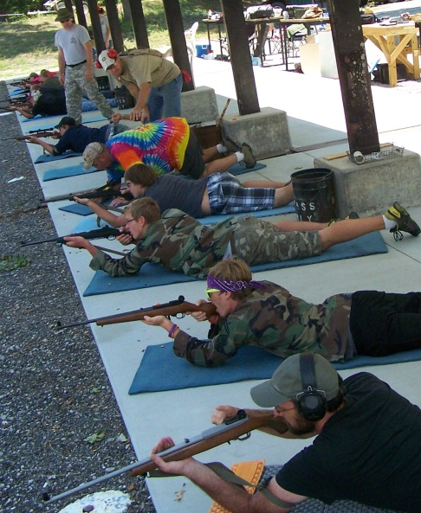
Appleseed Rifle Marksmanship Training
Can you shoot as good as a Revolutionary War Soldier?
Saturday Jan 24th – Sunday Jan 25th
Bone Creek Gun Club – 15 miles north of Pittsburg, KS
Register online and find more info at www.appleseedinfo.org
Limited to 60 shooters! Walk-ons are welcome if space allows.
Registration at 8:30 AM – Safety briefing at 9:00 AM – Shooting ends at 5:00 PM
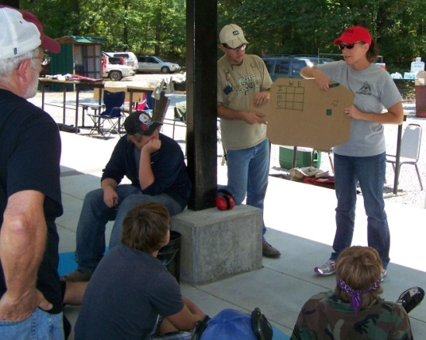
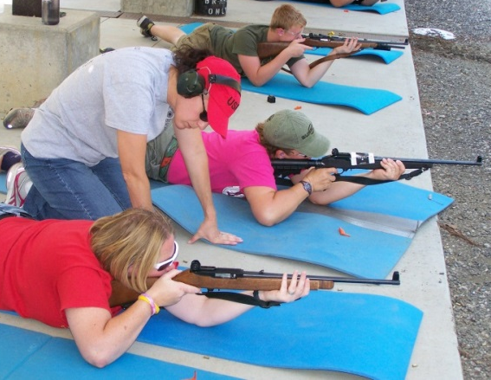
Appleseed/RWVA is a 501.c.3 non-profit organization and is affiliated with the Civilian Marksmanship Program
Revolutionary War Veterans Association professional instructors will teach precision rifle shooting and tell stories of American Revolutionary War exploits you never heard in school.

WHO CAN SHOOT: Anyone who can safely handle a rifle. We’ve had shooters as young as 5 and over 70.
Kids and adults, moms & dads and youth organizations are welcome.

COST: 2 days/1 day - Adults $60/$40, Under 18 $20/$15, LEO’s, All Military and Elected officials shoot free!

INFO: All shooting will be done on miniature targets at 25 yards that represent shots of 100 – 400 yards.
Any rifle is welcome but semi-autos with peep sights or scopes and removable magazines work best.
The short distance makes guns like Ruger’s 10/22 an excellent choice. Centerfire rifles are welcome if you can feed them! Many shooters will use AR’s with .22 conversions. A few loaners are available w/advance notice.

COMFORT GEAR: Bring a foam camping pad, water, snacks, lunch, chair & sunscreen. We’ll spend time shooting from standing, kneeling, sitting and prone so wear clothes you’re comfortable moving around in.
Your pad will be on concrete and you’ll be standing, sitting and kneeling on it. DO NOT bring an inflatable.
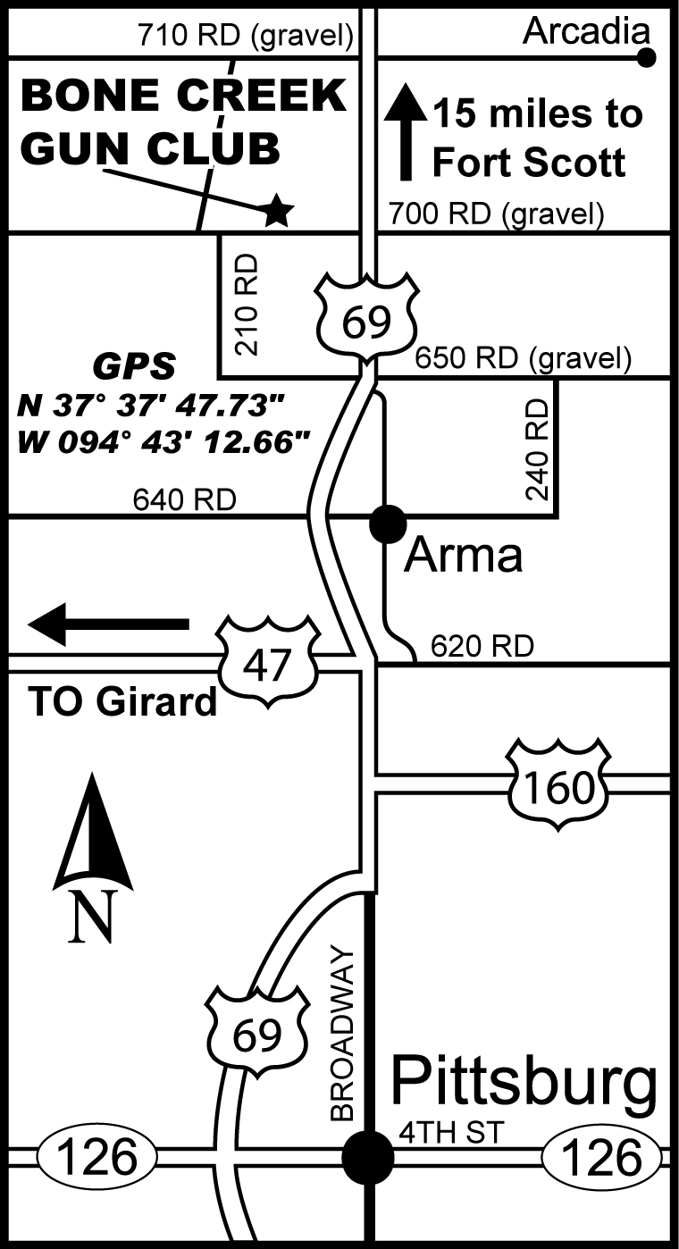
FACILITY: BCGC has a concrete pad and roof on the firing line. We have porta potties and that’s it. If you want water, food, chairs or anything else bring it with you. We will eat lunch on site. Check the weather forecast and dress accordingly!

AMMO: We’ll shoot 100 - 200 rounds a day. If you’re having trouble finding ammo contact organizer Roger Lomshek (below). He may be able to help locate reasonably priced ammo.

BE SURE TO BRING: Eye & ear protection, gun cleaning supplies and lube, at least two magazines (more are better) and food and drinks.

DIRECTIONS: Bone Creek Gun Club is 5 miles north of Arma, KS just 3/4 mile west of Hwy 69.
From Hwy 69 turn west on 700 RD (dirt road), go 3/4 miles then turn north at gun club drive.

Info: Roger Lomshek 620-249-0037 or roger@tailwindcyclists.com

The Rifleman’s Challenge: Score Rifleman (expert) on the first qualification test and get your entry refunded!
(If you’re that good we’d love to have you step up as an instructor and show new shooters how to do it)

