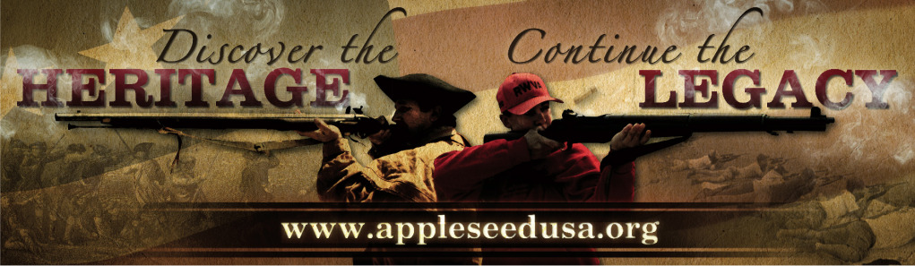
Project Appleseed
Rifle Marksmanship Clinics – Alaska 2014

Birchwood Range Shooting Park – Chugiak, AK April 19
Birchwood Range Shooting Park – Chugiak, AK July 12-13
Birchwood Range Shooting Park – Chugiak, AK August 9-10
Birchwood Range Shooting Park – Chugiak, AK Sept. 13-14
Birchwood Range Shooting Park – Chugiak, AK Oct. 11-12
Birchwood Range Shooting Park – Chugiak, AK November 1

{ Other Alaska Locations/Events: Majority Arms, LLC Range - Soldotna, AK May 17-18; Upper Susitna Shooters Range – Talkeetna, AK June 14-15; Tok Shooters Assn. Range – Tok, AK June 28-29;
Majority Arms, LLC Range - Soldotna, AK July 26-27; Upper Susitna Shooters Range –
Talkeetna, AK August 16-17; Majority Arms, LLC Range - Soldotna, AK Sept. 20-21 }

Project Appleseed is the sole project of the Revolutionary War Veterans Association (RWVA),
a 501(c)(3) organization. Founded in 2006, Project Appleseed and its volunteers are committed to bringing traditional rifle marksmanship skills and the story of April 19, 1775, to each and every American. Our goal is to teach the skills that are truly ours alongside the story, engaging each participant in our unique American heritage and encouraging all to become active and engaged citizens.

Cost is $60 per weekend for Adults, $20 for Youth under 18
Active Duty Military, Guard, & Reserves, Peace Officers, Elected Officials, Revolutionary War Re-enactors FREE.
Range fees are, if applicable, not included in registration fees and are payable on-site.
See event info on the website for more info, including directions and start times.
Rifles and ammunition are not supplied, but we can assist you with getting a loaner.

For more information about
Online Pre-Registration, What to Bring, and What to Expect, visit:

www.appleseedUSA.org

Or Contact: rwva@live.com or wthomas@gci.net

Marksmanship, History, Heritage*Marksmanship, History, Heritage * Marksmanship, History, Heritage

