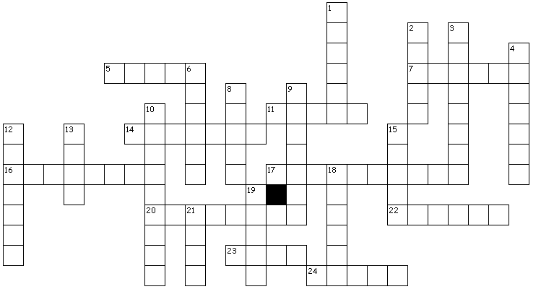
Across
5. The first shot on Lexington Green is known as “the shot heard round the _______”.
7. Which prominent alarm rider was captured by the Redcoats? (Last
Name)
11. What is the last name of militia commander who developed ring of fire military tactic?
14. What is the rank in the militia of John Parker?
16. Isaac Davis’s profession was __________
17. The name of the road back to Boston used by retreating Redcoats is ______ ____.
20. Paul Revere said “the ________ are out”
22. What is the first name of Isaac Davis’s wife?
23. How many father son pairs were separated by death on Lexington Green?
24. What is the last name of the man described by British soldiers as” Death on a pale horse”?

Solution: http://appleseedinfo.org/smf/index.php?topic=39212.0
Created by Puzzlemaker at DiscoveryEducation.com

Down
1. The raid on Lexington was meant to be a ______ mission.
2. When did the Revolutionary War begin _____ 19, 1775.
3. Levi Preston said “We had always _______ ourselves and we always meant to.”
4. How many militia members were on the Lexington Green?
6. Samuel Prescott’s profession was ________
8. What is the last name of military officer who led expedition to Concord?
9. The Revolutionary War began at _______ Corner.
10. The last name of “old Yankee woman” who captured several of the King’s Grenadiers?
12. Lord Hugh Percy and General Thomas Gage both worked for the King of ________.
13. “You will never know how much it _______ the present generation to preserve your freedom.”
15. The ________ Bridge was where the Redcoats turned and ran from the colonists.
18. The walk back to Boston was how many miles?
19. What is the last name of the first militia officer to die on April 19, 1775?
21. What is the last name of the British military commander of Boston?

