2012 Spring Schedule

(Additional and national dates added daily, visit www.rwva.org for updates)
Date: | Start Time: | Location:
February 23-24,2013 | 8:30 am Sat | Kingman, AZ
March 16-17, 2013 | 8:30 am Sat | Boulder City, NV
Patriot’s Day Shoot  Apr 20-22, 2013 | 8:30am Sat | Las Vegas, NV
Patriot’s Day Shoot  Apr 20-22, 2013 | 8:30am Sat | Kingman, AZ
May 18-19, 2013 | 8:30am Sat | Boulder City, NV
Jun 22-23, 2013 | 8:30am Sat | Glen Helen, CA
October 12-13, 2013 | 8:30am Sat | Kingman, AZ
Ladyseed  October 12-13, 2013  Join us on our Facebook page:  Southern Nevada Appleseed  Email: SNVAppleseed@gmail.com  Phone: 702-530-3119 | 8:30am Sat | Las Vegas, NV  (Ladies Only)

The Appleseed Project
History & Heritage program + Rifle Clinic

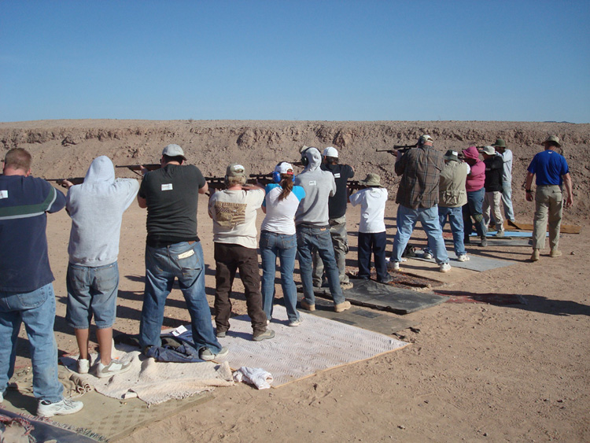
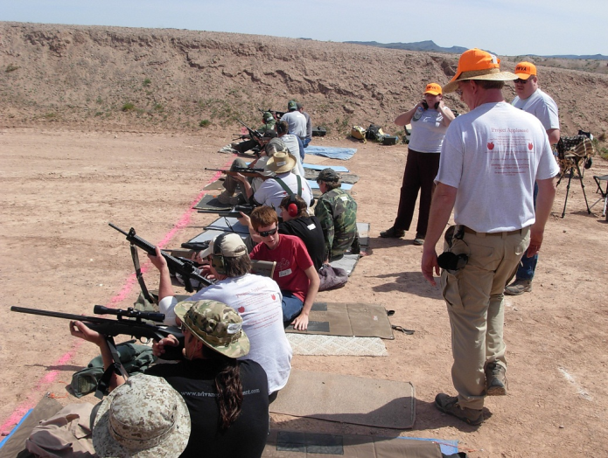

Marksmanship: The Traditional American Skill

The fundamentals of American marksmanship are taught beginning with firearms safety and moving on to shooting positions, body & breath control and the six steps to firing the shot. Shooters of all skill levels are successful with our program. Casual shooters, competition shooters, hunters, and “plinkers” can benefit from our program.

FREE Registration for Active Duty Military, Active Law Enforcement, and Elected Officials
REDUCED Registration for Women and Youth
(Range fees still apply). (Rev – 2/13)

(

History & Heritage Program:

Bringing the Past into the Present

The Appleseed Program, brought to you by the Revolutionary War Veterans Association, is a 501(c)(3) non-profit organization dedicated to the teaching of American history, heritage, and traditional marksmanship skills. Our instructor teams travel the country sharing the difficult choices and heroic actions that our great founders made on behalf of us, their “posterity”.

Our heritage program brings the first two days of the Revolutionary War vividly into the modern day with the kind of care and immediacy that is absent from schooling today.

Appleseed is dedicated to bringing the people and events of April 19, 1775, to each and every American. These are our stories and in them is the hope for our shared future.

Appleseed Project

appleseedinfo.org

Appleseed Project

appleseedinfo.org

Appleseed Project

appleseedinfo.org

Appleseed Project

appleseedinfo.org

Appleseed Project

appleseedinfo.org

Appleseed Project

appleseedinfo.org

Appleseed Project

appleseedinfo.org

Appleseed Project

appleseedinfo.org

Appleseed Project

appleseedinfo.org

Appleseed Project

appleseedinfo.org

