Appleseed Follow-Through Guide
Remember the 6th step of firing a shot – Follow Through? This guide helps you follow through after an Appleseed shoot to make the most of your experience. Study it and follow the given “prescriptions” to improve your marksmanship and your understanding of history, and most importantly, to do your part in saving the sinking ship that is the United States of America.
Marksmanship: Continue the Tradition

Safety Rules
- Always keep the muzzle in a safe direction.
- Do not load until give the “load” command.
- Keep your finger off the trigger until the sights are on the target.
- Make sure those around you follow the safety rules.

Safe Rifle
Magazine out
Bolt back
Safety on
Chamber flag in
Rifle grounded
Step back – no one touching the rifle
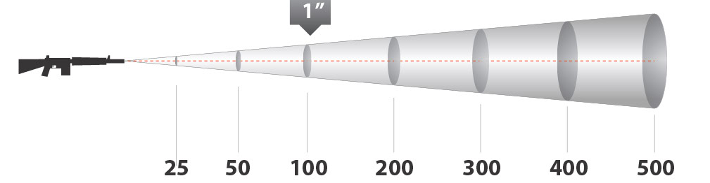

Six Steps of Firing the Shot
- Sight alignment
- Sight picture
- Respiratory pause
4a. Focus your eye on the front sight
4b. Focus your mind on keeping the front sight on the target
- Squeeze the trigger
- Follow Through:
- Hold the trigger back
- Take a mental snapshot of where the front sight was when the round went off.

MOA (Minute of Angle)
1 MOA = 1” per 100 yards
Translate: from inches to minutes to clicks
Appleseed standard: shoot consistently within 4 MOA
(that’s 1” groups at 25 yards; 4” groups at 100 yards; etc.)

Before your next Appleseed event:
- Memorize Safety Rules, Safe Rifle, and 6 Steps
- Practice prone, sitting, and standing positions
- Practice using Hasty and Loop slings
- Practice finding and adjusting your Natural Point of Aim in each position.
- Practice each of the 6 steps of firing a shot - then practice them all together, dryfiring
- Rehearse stages 2 and 3 of the AQT (transitions from standing to sitting or prone)
- Dryfire AQT's
- Be comfortable adjusting your sights using inches, minutes, and clicks
- Study the Shot Group Analysis page
- Teach someone else

Your first goal is stability and repeatability: find the position/adjust NPOA/etc. correctly 5 times in a row.
Your next goal is speed: keep repeating the exercise until you can do it quickly, yet still correctly. Stay smooth.
Remember: perfect practice makes perfect.
History: Remember the Heritage

Books
- Paul Revere's Ride by David Hackett Fischer
- The American Revolution by John Fiske
- 1776 by David McCullough
- Common Sense by Thomas Paine
- Lexington and Concord by Arthur B. Tourtellot (also published as William Diamond’s Drum)
- The Bulletproof George Washington by David Barton
- Federalist Papers & Anti-Federalist Papers
- Constitution and Declaration of Independence

Courses/organizations
- Free Constitution courses from Hillsdale College (constitution.hillsdale.edu)
- Patriot Academy (patriotacademy.com)
- TeenPact (teenpact.com)
Little People Q&A
- Why were the Regulars out on April 19, 1775? To seize the gunpowder stored at Concord.
- What were the names of three men who rode to warn the colonists the night of April 18, 1775? Paul Revere, William Dawes, Dr. Samuel Prescott
- Why were TWO lanterns hung in the church steeple? “One if by land, two if by sea….” The Regulars were ferried across the river.
- What did Paul Revere call out on his ride? “The Regulars are out!”
Thought questions for discussion or essays
- What is the importance of April 19, 1775 to your American heritage? What’s its significance in your life today?
- The colonists who stood up to the Regulars committed treasonous acts, punishable by hanging. Answer honestly: would you have stood with them? Why or why not? Would your answer be different if you knew that you would lose the war?
- A member of the Lexington training band said to Captain Parker, "There are so few of us it is folly to stand here." What issues, principles, or rights do you consider worth standing for in our nation today, even if few or none stand with you?
- What is the American Revolution, and how is it distinct from the Revolutionary War?
- John Adams wrote, "Posterity, you will never know how much it cost the present generation to preserve your freedom. I hope you will make good use of it. If you do not, I shall repent in heaven that ever I took half the pains to preserve it." How can you "make good use" of your freedom in the next month? Year? Ten years?
- Ronald Reagan stated, "Freedom is never more than one generation away from extinction." What can you do to safeguard the freedom of your great-grandchildren?
- What is liberty?
- Who fired the first shots at Lexington Green? Explain your answer.
- How was teamwork important on April 19, 1775? Give examples.
Key figures from April 19, 1775
American colonists: Dr. Joseph Warren, Paul Revere, William Dawes, Dr. Samuel Prescott, John Hancock, Samuel Adams, Captain John Parker, Jonathan Harrington, Colonel Barrett, Luther Blanchard, Major Buttrick, Captain Isaac Davis, General William Heath, David Lamson, Samuel Whittemore, Hezekiah Wyman, Colonel Timothy Pickering
Some women and girls who aided the cause of the American Revolution: Sybil Ludington, Elizabeth Zane, Hannah Davis, Abigail Adams, Prudence Wright
British commanders: General Thomas Gage, Colonel Francis Smith, Major John Pitcairn, Major Mitchell, Lieutenant Jesse Adair, Lord Hugh Percy
Your To-Do List: Continue the Legacy

"Posterity, you will never know how much it cost the present generation to preserve your freedom. I hope you will make good use of it. If you do not, I shall repent in heaven that ever I took half the pains to preserve it."
(John Adams)

“We the People” founded our nation, and “We the People” have a responsibility to run our government. We as a nation have shirked our duties because we’re ignorant – we have no idea what’s happening in our government. Or we’re lazy – we’d rather not take the trouble. Or we’re apathetic – we don’t really care. That changes now, with you. Grab a bucket and help us bail the sinking ship!

- Make a list of all your elected officials and their contact information.
- Sign up for free weekly email updates on how your congressmen vote at MegaVote – www.congress.org/congressorg/megavote/
- Give your elected officials regular feedback. (see below)
- Read and study the Constitution and Declaration of Independence.
- Study current issues and decide your position on them. Be able to defend it. This is part of being “men who know what they are about,” as Lord Percy referred to the colonists after April 19, 1775.
- Write letters to the editors of local papers to express your opinion on current issues.
- Join a group in your area with like-minded people who are making a difference. Search Meetup.com.
- Identify candidates you can support; volunteer for their campaigns.
- When there are no existing candidates you can support, find someone else to run for that office.
- Run for office yourself.
- Don’t forget the importance of lower-level offices. Put solid candidates in at local levels.
- Volunteer with the RWVA Appleseed Project as a Blue Hat (“Applecore” – support/administrative) or Orange Hat (Instructor in Training – after shooting to Rifleman standards).
Contacting your Elected Officials
- A phone call is quick, easy, and effective.
- Let them know how you want them to vote.
- Remember to thank them for good votes.
- You don’t have to be a skilled debater; just state your name, the pertinent issue, and your request.
- Resource for contact info: http://www.usa.gov/Contact/Elected.shtml
More Appleseed Resources:
- Rifleman Radio Show – blogtalkradio.com/AppleseedRadio, Thursdays 7-9PM CST
- Appleseed website – appleseedinfo.org
- Appleseed Forum – http://appleseedinfo.org/smf/index.php
- Appleseed Facebook pages – search for your state’s page and “like” it
- Appleseed Homeschoolers – facebook page and board on the forum
- Appleseed Online Stores – targets, apparel, slings, and more – http://appleseedinfo.org/stores.html

